AWAITINGTHENWAJIUBAPHENOMENON(8)

ReinventingtheNigerianwheel.

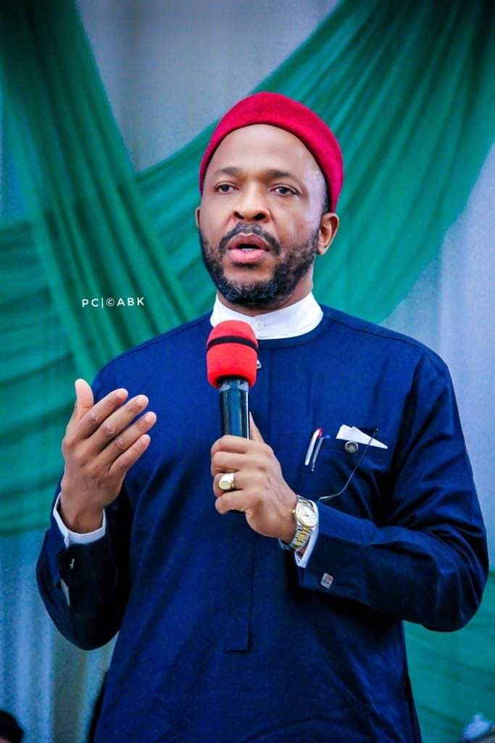

PASCHALEGERUE

Thank you Hon(Dr) Emeka Nwajiuba for the superlative performance, scintillating erudition and profound propositions on national rebirth made at the Channels Politics Today interview anchored by the irrepressible Seun Okinbaleye last night, 15th may, 2022. Nigerians no doubt havefoundaleaderinyou.Weareonlywaitingforyourparty,theAllProgressiveCongress(APC) to do the needful and present you to to the nation as their flag bearer in the 2023 Presidential election.

We have come to a stage in this country where we need to step back to think of what to do to recover Nigeria, how to do it and who will do it. By the 1960s up to the unfortunate debacle of
1965/66 and the civil war, the engine of growth of the nation was on full throttle, 100% acceleration and with excellent drivers. A mixture of imponderable things altered our thought processes and began to reverse the growth of the nation. We completely lost the momentum generated by regionalism and their neo welfarist orientation. Emerging from this spectacular race in the first republic, the post war economy created a deceptive boom that was based on
the importation of just everything without an agenda of how to stimulate local production. Fueled by oil money and stuck in this nebulous trap of importation of everything, the fundamental orientation of Nigerians for hard work and ingenuity snapped. It was in this fatalistic condition that we swallowed the externally applied neo liberal pills of economic liberalization policies of privatization, deregulation, globalization, free trade and all that which were expected to reduce government spending while accelerating privator interventions and growth.Theseweregoodsoundingpoliciesthatneverfactoredournationalcapacitytomanage their unintended consequences. One offshoot of such unintended consequences was that the wealth of the nation was effectively put in a few 'non' productive hands who got so wealthy by this accident of history and began to influence the policy direction of the nation. The result is the economicculdesacwe have foundourselves in andwhich effectively is stagnation.In truth however, we are not even in a state of stagnation. We are in a worse situation of receding backwards. As Albert Einstein posited, it is only a mad man that does the same thing all over againandexpectsadifferentresult.Nodifferentresultwilleverhappenifwedonotchangethe developmentparadigmofthisnation.

WhatNigerianeedsatthemomentisaneffective,youngandagileleaderthatwillfasttrackthis economywithdisruptivethinkingandextraordinaryexecution. Wemustdrawourrunrateasa nation by effectively evaluating how far behind we are from the developed nations, especially theemergingnationsofAsiaandkeepstrictlytotheestimatedspeedofannualgrowthratethat will make us catch up with these nations at a precise year/time point. This is doable with Hon(Dr) Emeka Nwajiuba as the next President of the Federal Republic of Nigeria. A legislative agenda to drive this transformation will be pursued while the structure for the triumph of the rule of law will be established. The regulatory template in all facets of economic activities will be geared to measurable growth and extent of ease of doing business. There is so much to learn in this new drive for national resurgence from the profound effect the transformation of China and India is having on global economy. Our future with these emerging economies shouldbebasedonmodellingoureconomyonwhatmadethemcontemporarygiantsandnota fixationonborrowingfromthem.Whilerecognizingthatinterdependenceofnationscannotbe avoided,itis howeverimportantas amatterofnationalprideforNigeriatocreatesubstantially andendogenously,herownwealth.

China and India which are today globally respected share some peculiarities with Nigeria. The threecountrieshavesamecomplexityarisingfromhighpopulationgrowth,hugelandmassand diverse ethnicities even though China is largely homogeneous. This is however where the comparisonstops.ChinaandIndiahavemadetremendousprogressinthepasttenyears.They have created new market opportunities predicated on enhanced domestic purchasing power, greater competitiveness as producers of selected products and aggressive external trade via export of products and skills. India for instance is a key player in global software and programming industry. For the two countries, growth in agriculture has dovetailed to industrial growth and escalation of income from non agricultural sectors. This was made possible in a sequenceofvaluechainsthatstimulatedriseinincome,domesticconsumption,highersavings rate and programmed institutional interventions including conventional banking and microfinance Institutions that transfer these savings to physical capital investments in the non
agricultural sectors. In all these, no person mentions oil or what I may call the hydrocarbon distractionwhichisnowmoreorlessthebiggestnuisancetostretchingourgrowthcapabilities in Nigeria as a nation. The highly successful China Township and Village Enterprises ( TVE) model can be replicated in Nigeria. Nigeria can achieve self sufficiency of these towns and villagesbycreatingroad,electricity,internetaccessandfinancingmodeltosuitthecomparative advantages which our diverse towns and villages have. With this got right, citizens will be kept productively busy, our per capita GDP will rise and criminal activities manifesting as armed robbery,kidnapping,banditryandterrorismwilltakeabackseatifnotdisappear.

Nigeria will be in upward swing if hard decisions are taken now to elect the right person as Presidentin2023.Letusdoawaywithprimordialsentimentsandgoforaleaderthatwillcreate a Marshall plan for the nation's economic recovery and execute same with precision. The cap for this generational challenge fits Hon(Dr) Emeka Nwajiuba perfectly well. His intellectual reflexes are in turn with the speed required for the ardous task ahead. Hon(Dr) Chukwuemeka Nwajiuba has a lot of positive energy in him. Importantly, he has the humility to win as a team player.Inhim,APCasapartyhastheacetodefeatotherpartiesintheforthcomingPresidential electionandretainpower.Ipraythedelegateswilllistenanddotherightthingattheprimaries.

PaschalEgerueisaLagosbasedInsuranceandManagementConsultant.

